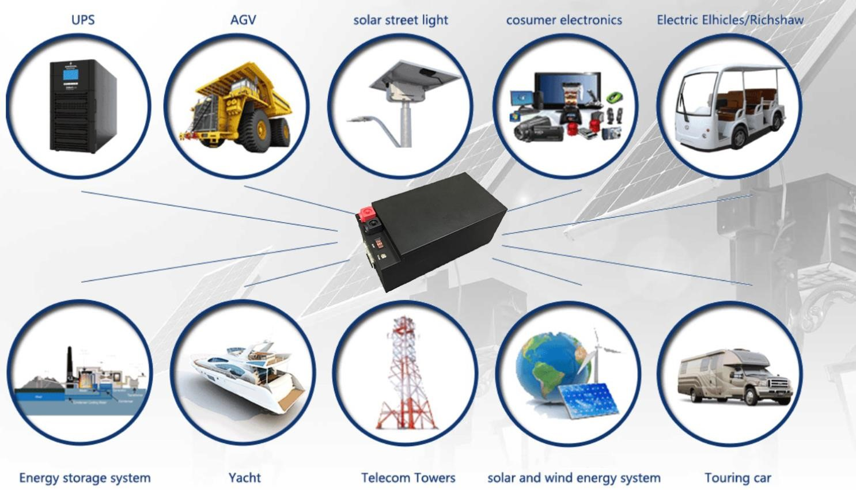

51.2V 100Ah LiFePO4 Battery

Battery Model： 51.2V00AH
Battery Material： LiFePO4
Nominal Voltage： 51.2V
Nominal Capacity： 100AH

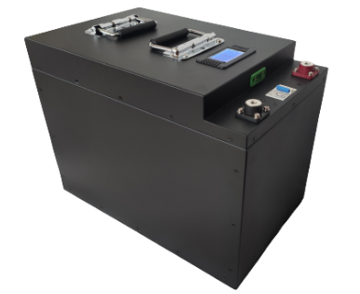
Item | Specification
Cell Type | CATL Brand LiFePO4 Prismatic Cell
Nominal Capacity | 100Ah
Nominal voltage | 51.2V
Charge Cut-off Voltage | 58V±1.0V
Discharge Cut-off Voltage | 40V±2.0V
Max Charge Current | 50A-100A
Continuous Discharge Current | 150A
Peak Instantaneous Discharge Current | 300A
Communication Port | RS485
SOC Display | LCD Voltage Display
Battery Housing | Metal Casing, White
Operating temperature | Charging: 0℃~45℃
 | Discharging: -10℃~60℃
Storage temperature | -5℃~35℃
Storage Humidity | ≤75% RH
Standard environmental condition | Temperature：25±2℃
 | Humidity: 45-75%RH
 | Atmospheric Pressure: 86-106 KPA
Discharge/Charge connector | Screw In Terminals
(Default) Metal Case Dimensions | 560L x 240W x 230H (mm)  480L x 300W x 230H (mm)
Connection | Support 4 units in Parallel connection
Net Weight | Approx.: 50kg

General Performance
Item | Test Methods and Condition | Criteria
0.2C Capacity | After standard charging, hold battery for 10mins, then discharge at 0.2C to voltage 40.0V, recording the discharging time. | ≥ 100Ah
Cycle Life | Constant current 0.2C charge to 55.0V, then constant voltage charge to current declines to 0.01C, rest 10min constant current 0.5C discharge to 44.0V rest 10min.  Repeat above steps till continuous discharging capacity Higher  than 70% of the Initial Capacities of the Cells | ≥5000 times
Capability of keeping  electricity | 20+/-5℃, After standard charging, hold the battery for 28days, then discharge at 0.2C rate to voltage 38.0V, recording the discharging time. | ≥160min

◼ Environment Performance
Item | Test Methods and Condition | Criteria
Discharge at high temperature | After standard charging, shelve the cells 4h at 60+/-2℃, then discharging at 1C to voltage 40.0V, recording the discharging time. | ≥40min
Discharge at low temperature | After standard charging, shelve the cells for 16h at -20+/2℃, then discharging at 0.2C to voltage 40.0V, recording the discharging time. | ≥150min
Thermal shock | Put the battery cells in the dryer box.  The temperature of the oven is to be raised at 5+/-2℃ per minute to a temperature of 100+/-2℃ and remains 30 minutes. | No fire, no smoke

Safety Characteristic
Item | Test Methods and Condition | Criteria
Over charge testing | At 23+/-5℃, charging cells with constant current 2C to voltage 60V, Stop test till cells temperature 10 lower than max temperature. | No smoke or  fire
Over discharge testing | At 23+/-5℃, According to the requirements of standard charge, the cells will be discharge to cut-off voltage, then connect with external load of 30 ohm for 24 hours. | No fire, no smoke, no leakage.
Short-circuit testing | At 23+/-5℃, After standard charging, connect cells anode and cathode by wire which impedance less than 200+/-20m Ω, shelve the battery for 6 hours. | No smoke or  fire

※Above testing of safe characteristic must be with protective equipment.

◼ CAUTIONS IN USE
To ensure proper use of the battery please read the manual carefully before using it.

Handling
▪ Do not expose to, dispose of the battery in fire.
▪ Do not put the battery in a charger or equipment with wrong terminals connected.
▪ Avoid shorting the battery
▪ Avoid excessive physical shock or vibration.
▪ Do not disassemble or deform the battery.
▪ Do not immerse in water.
▪ Do not use the battery mixed with other different make, type, or model batteries.
▪ Keep out of the reach of children.

◼ Charge and Discharge
▪ Battery must be charged in appropriate charger only.
▪ Never use a modified or damaged charger.
▪ Do not leave battery in charger over 24 hours.
- Storage
▪ Store the battery in a cool, dry and well-ventilated area.

- Disposal
▪ Regulations vary for different countries. Dispose of in accordance with local regulations.

Battery operation instruction
- Charging
Charging current Cannot surpass the biggest charging current which in this specification book stipulated.
Charging voltage Does not have to surpass the highest voltage range which in this specification book stipulated.
Charge temperature The battery must carry on the charge in the ambient temperature scope which this specification book stipulated.
Uses the constant electric current, and the constant voltage way charge, the prohibition reverse charges. Incorrect connection of the battery positive electrode and the negative terminal can damage the battery.

- Discharging current
The discharging current does not have to surpass this specification book stipulation the biggest discharging current, the oversized electric current electric discharge can cause the battery capacity reduction and to cause the battery to overheat.

- Discharge temperature
The battery discharge must carry on in the ambient temperature scope which this specification book stipulated.

- Over-discharge
After the short time excessively discharges charges immediately cannot affect the use, but the long time excessively discharges can cause the battery the performance, battery function losing. The battery long-term has not used, has the possibility to be able to be at because of its automatic flashover characteristic certain excessively discharges the condition, for prevented excessively discharges the occurrence, the battery should maintain the certain electric quantity.

- Storing the Batteries
The battery should store in the product specification book stipulation temperature range. If has surpasses above for one months the long time storage, suggested you should carry on additional charge to the battery.

◼ Chemical Reaction
Because batteries utilize a chemical reaction, battery performance will deteriorate over time even if stored for a long period of time without being used.
In addition, if the various usage conditions such as charge, discharge, ambient temperature, etc.
are not maintained within the specified ranges the life expectancy of the battery may be shortened or the device in which the battery is used may be damaged by electrolyte leakage. If the batteries cannot maintain a charge for long periods of time, even when they are charged correctly, this may indicate it is time to change the battery.

◼ NOTICE
Before using the battery pack/packs, pls DO NOTE BELOW REMINDERS:

# Battery appearance visual check:
Carefully open the protective carton/wooden box Once batteries received.
Pls do check if the batteries with any scratches or impacted.
If everything goes well, pls go on.
If any, pls contact us at the very first time without any delay.

# Do correctly connect the battery with Positive Pole and Negative Pole (usually Red + Black -).
Otherwise short circuit would possibly happen due to wrong connection on +/- terminal.

# Connection Use Notice:
Do keep the battery packs within 1.0VDC voltage difference if you are going to connect them in series or parallel.
The smaller voltage difference (0.1V-1.0V) of the battery packs the better for batteries connection.

# DO NOT discharge the battery pack till 0% Power which is not that good to keep longer life. Pls charge the battery to 80% (100% would also be fine) and DO Recharge the Battery while they are discharged/used down to 20% Power.

# DO Recharge the Battery Packs every 3 months if they are shelved/not used for long time.

