PC operation instructions
At this time the program installation is available in CHINESE only. However, once the program is installed there is an ENGLISH VERSION. Please see the instructions below and just use the button sequence to carefully install until you can open the program in English. We apologize for the inconvenience and are working to improve the program’s installation process.

1. Decompress the compressed file according to the following figure, and keep clicking the next step.
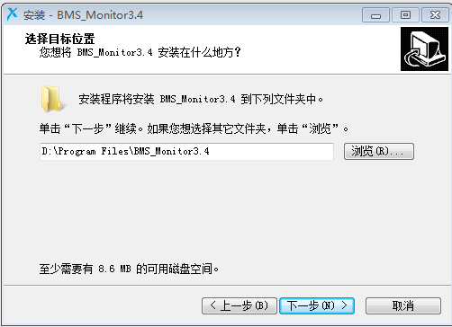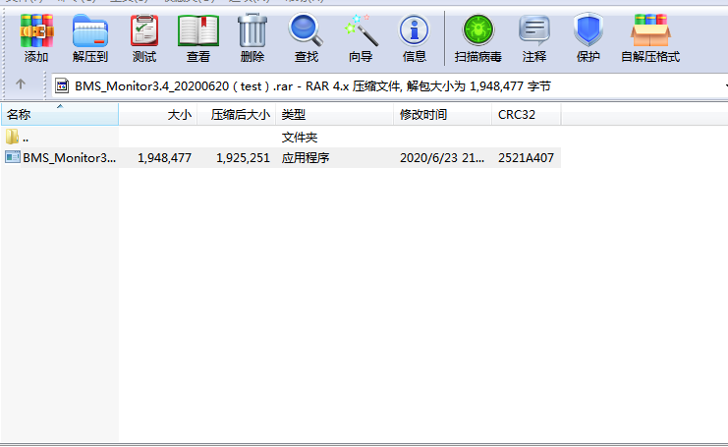
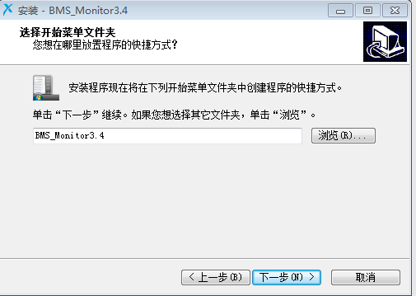
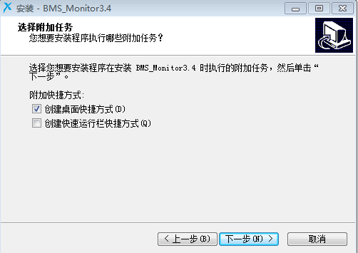
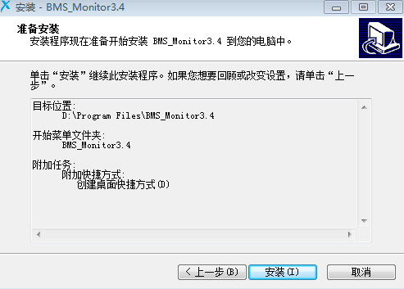
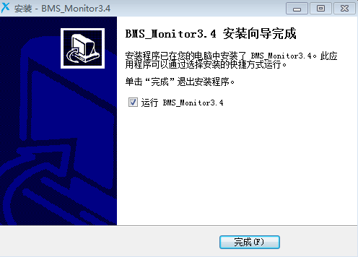

2. After decompression is complete, the following host computer interface will appear:
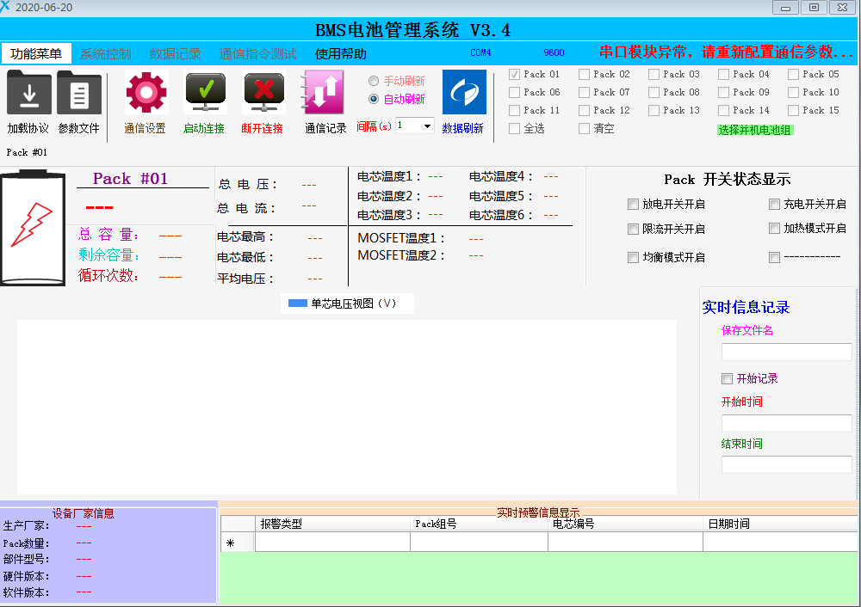

To access the English Version, follow the button sequence here:
- fifth button from the top left, second choice on pulldown.
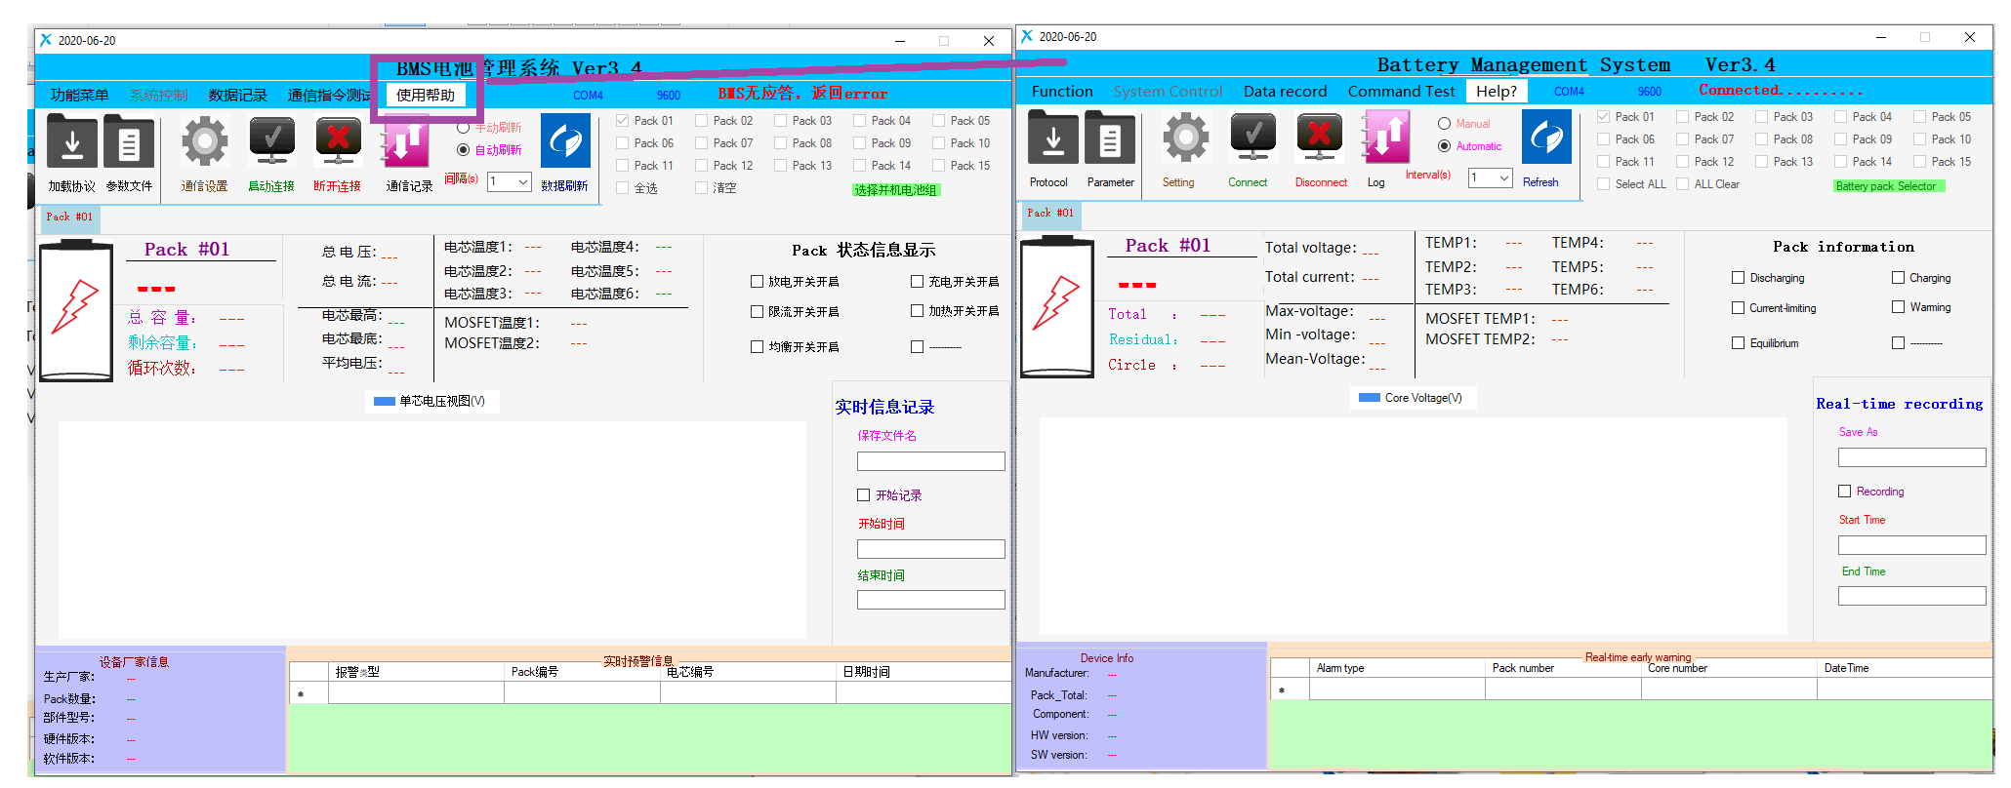
- Select “English”

3. This is needed to connect the USB to 485 cable that is provided with your battery. Please connect it to the USB of the computer, and then open the driver wizard.
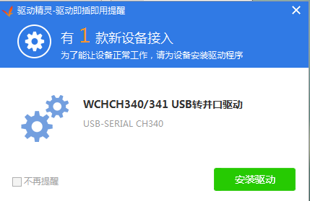：

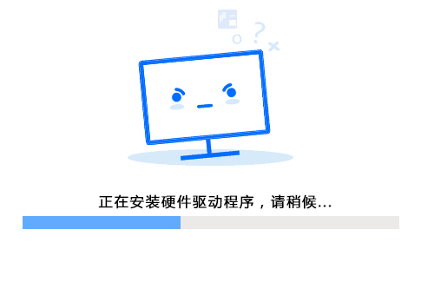

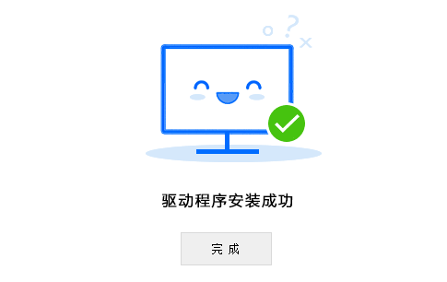

4. After the driver is installed successfully, go to open "My Computer", right-click and select properties, select the device manager, select the port, the CH340 you find is the COM, and open the settings as shown below:
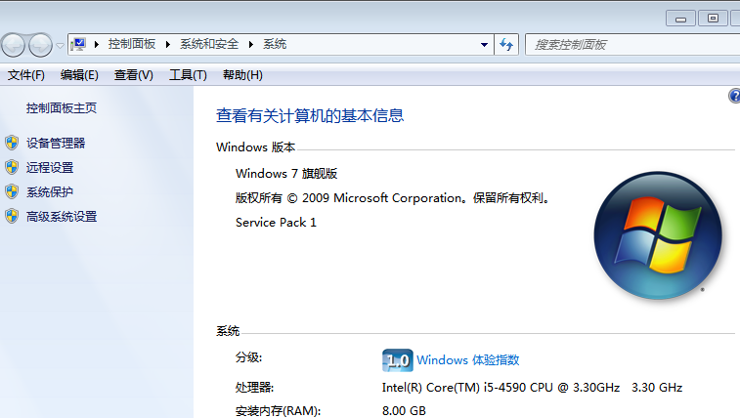
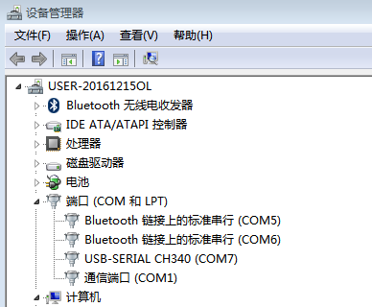

4. Through the above picture, we find that CH340 is com7, so we turn on the upper computer, open the settings, select COM7, and then click to start the connection, so that the upper computer can be connected to the battery pack:
